# CS 340 README Template

*Use this template to complete your README file. When completing the template, keep the headings as they are so that your document has a clear organization. Remove the italicized prompt text after you have completed each section for a polished final document.*

## About the Project/Project Title

In this project we are using CRUD methodology. This stands for Create, read, update, and delete. This was designed to create functionality in python and used in a Mongo database.

## Motivation

In working with Python, the Mongo database should have an easier time running the Mongo server using less resources. The Python code should help the CRUD methodology during the time of running this database.

## Getting Started

*To get started install the file, and check user Identifications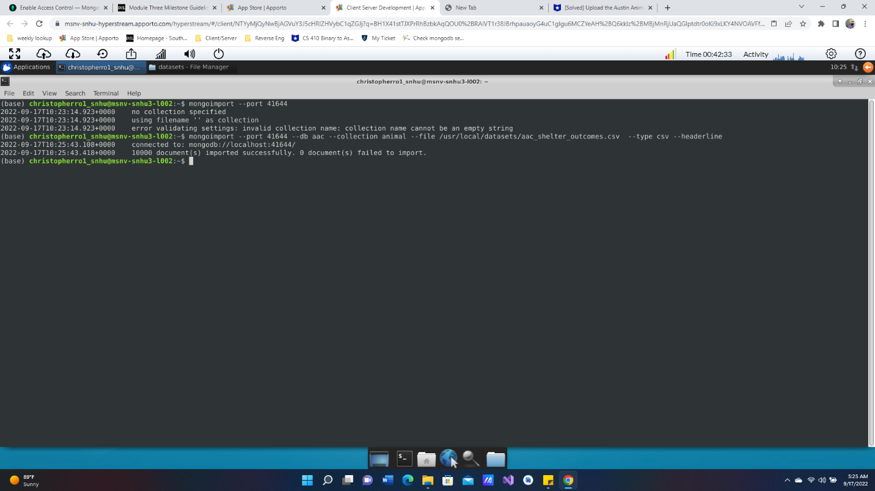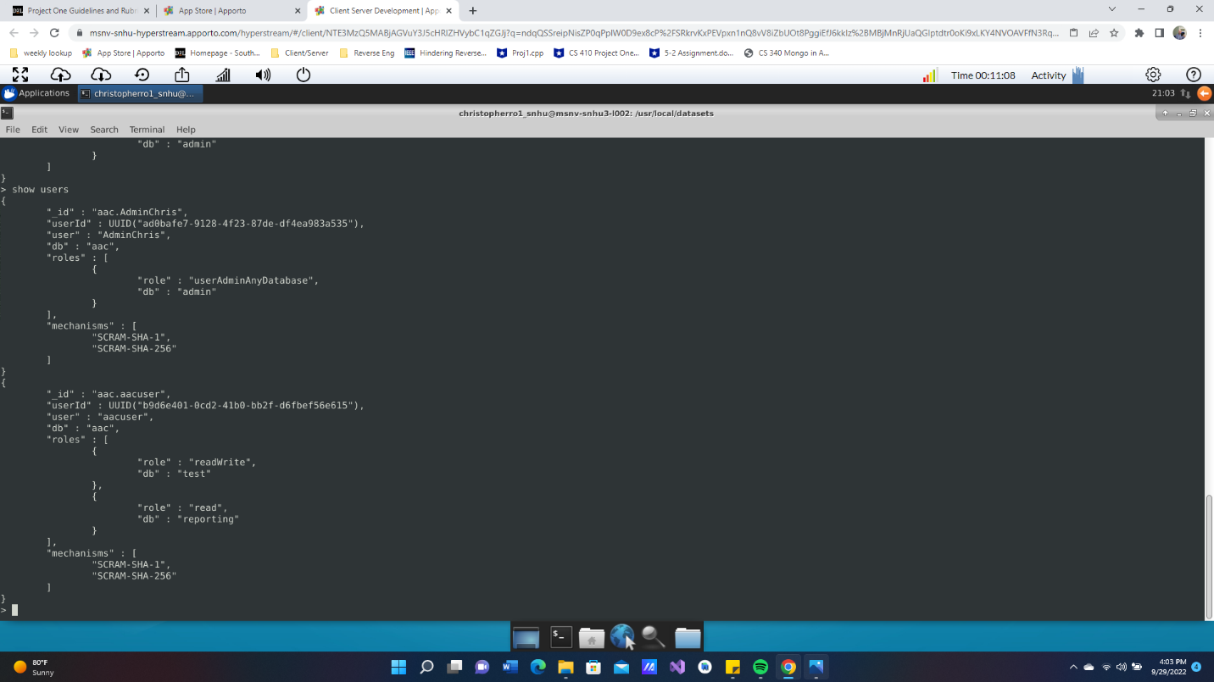*

## Installation

Using Jupyter notebook and the terminal line to use MongoDB

## Usage

*Use this space to show useful examples of how your project works and how it can be used. Be sure to include examples of your code, tests, and screenshots.*

### Code Example

*Codes from the py that use CRUD- create,read,update,and delete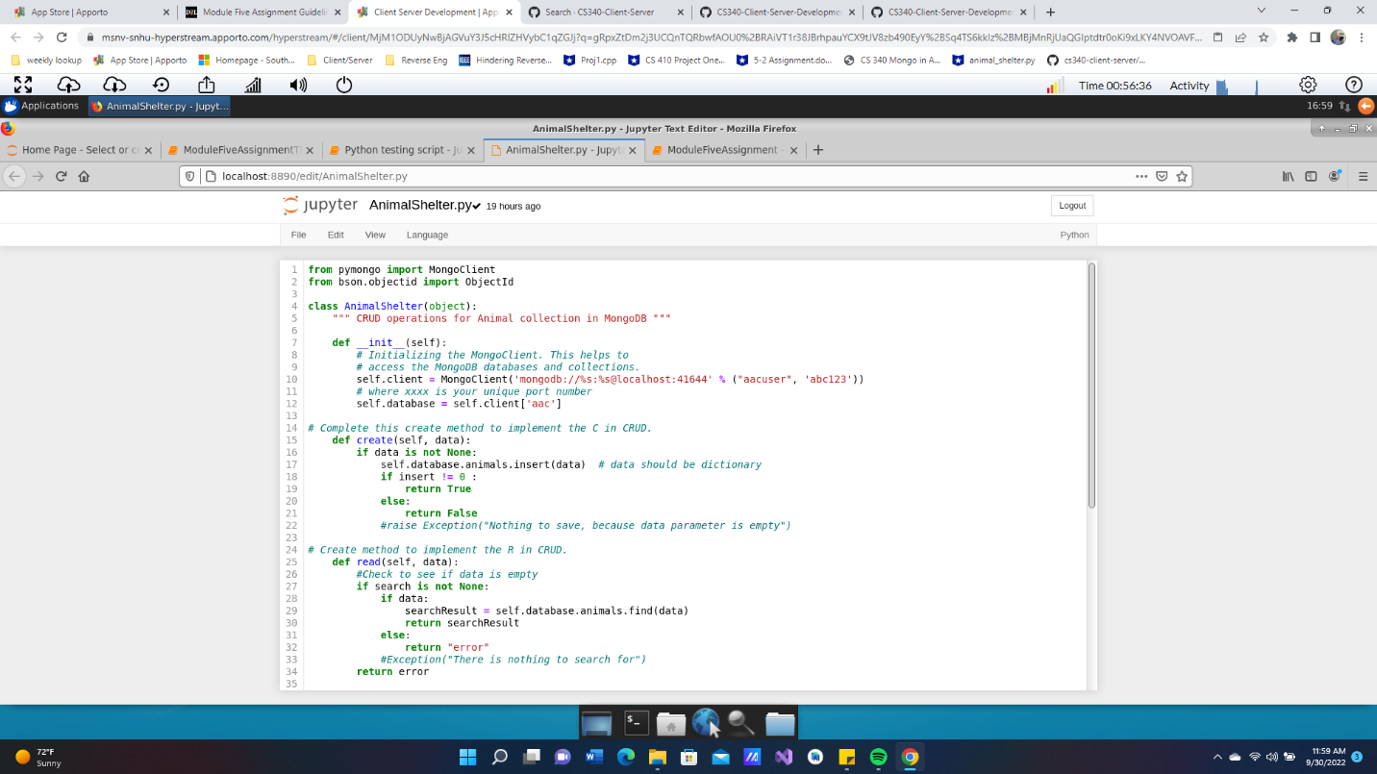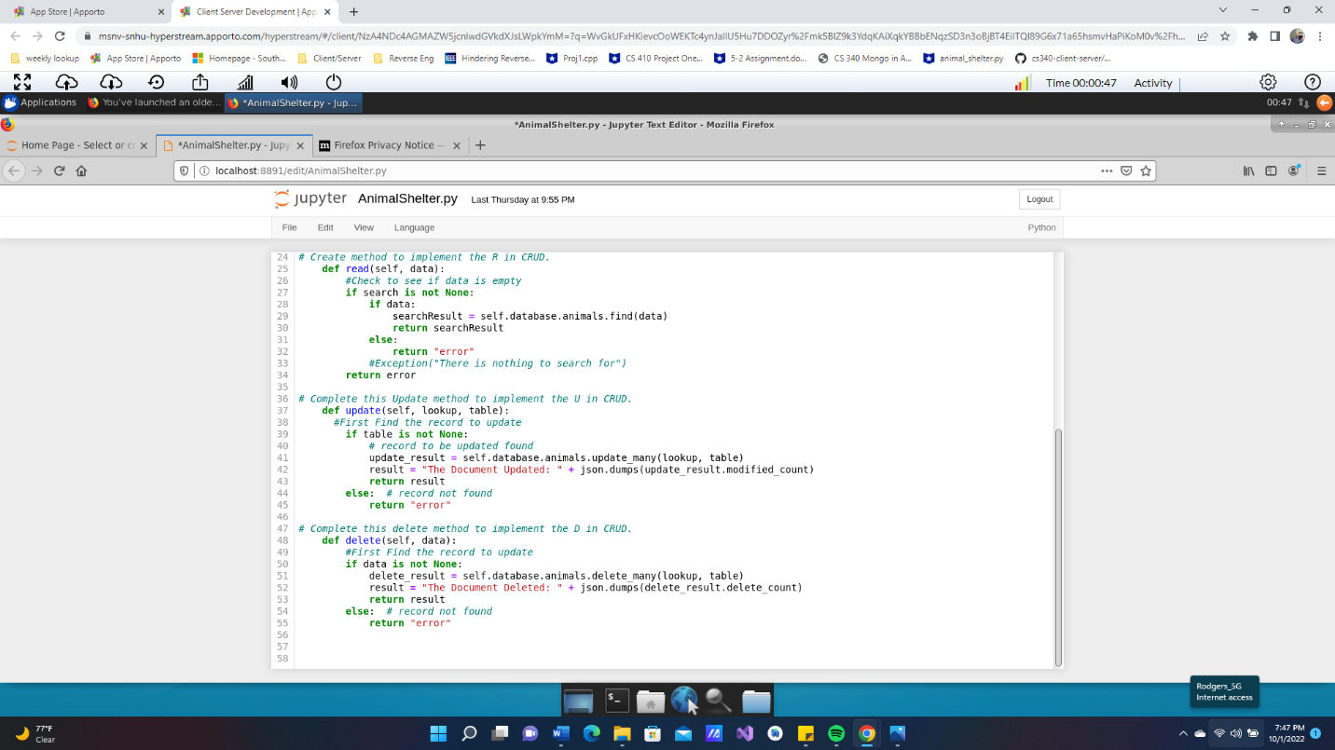*

### Tests

*Describe and show how to run the tests with code examples.*

### Screenshots

*Provide screenshots that demonstrate your work.*

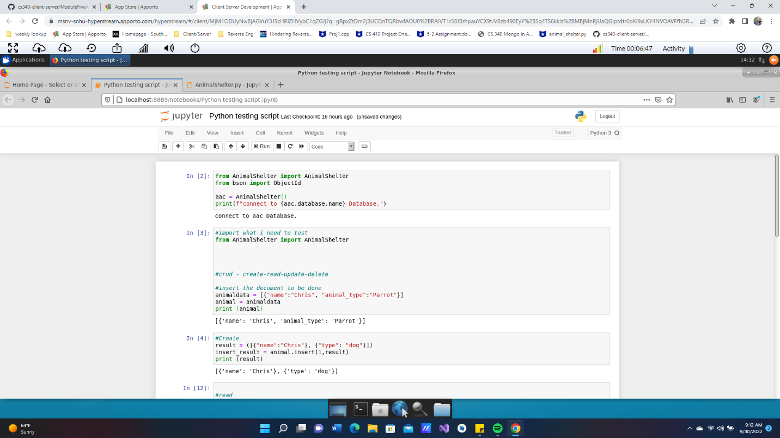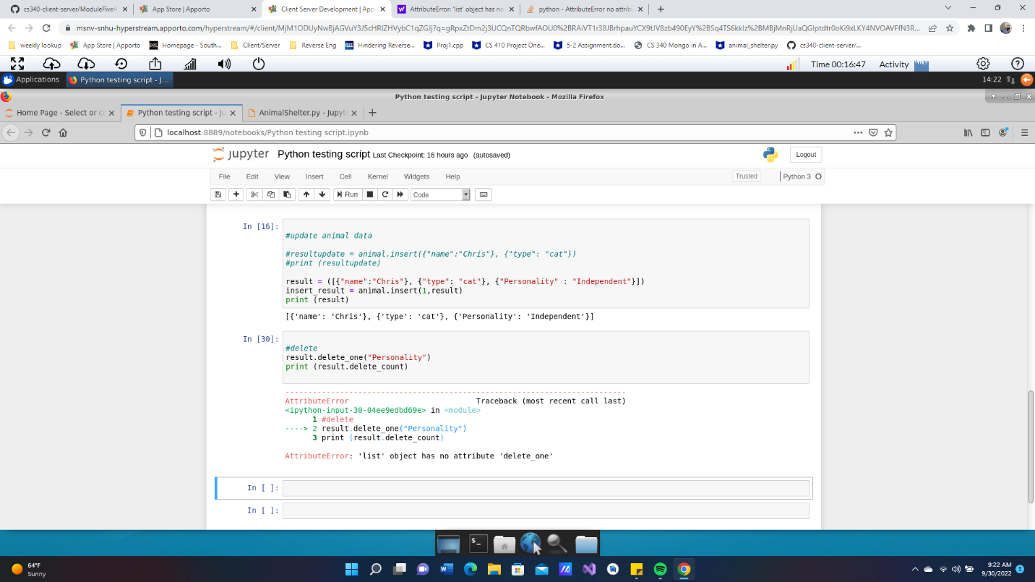

## Contact

Chris Rodgers

Christoher.Rodgers3@SNHU.edu